**Problem 1**

B-P

C-P

**C**

**A**

3

**P**

**B**

3

A

C

25 mm

20 mm

30 mm

A-P

**Problem 2**

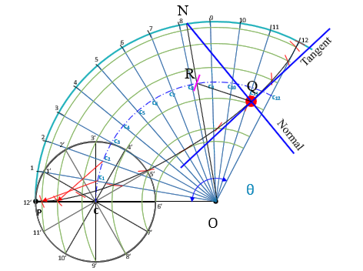

**OP = Radius of directing circle = 100 mm**

**PC = Radius of generating circle = 20 mm**

**θ = r/R x 360º = 20/100 x 360**° **= 72**°

**Problem 3**

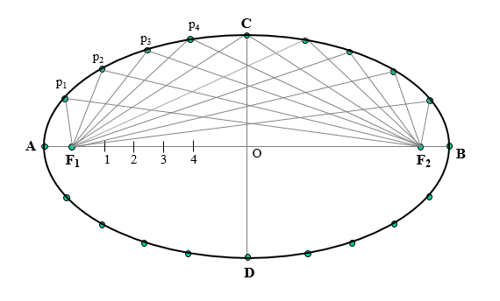

55 mm

90 mm

**Problem 4**

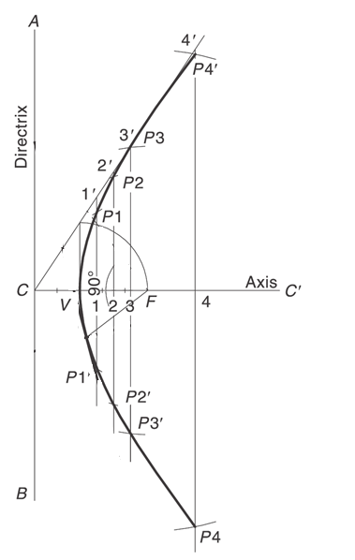

16.7 mm

CF = 50 mm

⸫ CV+VF = 50

e = 2

⸫ VF / CV = 2 => VF = 2 CV

⸫ 3 CV = 50

=> CV = 50 / 3 = 16.7 mm

50 mm